

T700**(E)**(J30)T

**NATIONAL CERTIFICATE**

# FITTING AND MACHINING THEORY N2

(11022032)

**30 July 2018 (X-Paper)**

**09:00–12:00**

**Calculators may be used.**

**This question paper consists of 10 pages and 1 formula sheet.**

## DEPARTMENT OF HIGHER EDUCATION AND TRAINING

**REPUBLIC OF SOUTH AFRICA**

NATIONAL CERTIFICATE

FITTING AND MACHINING THEORY N2

TIME: 3 HOURS

MARKS: 100

**NOTE**: If you answer more than the required number of questions, only the required number will be marked. All work you do not want to be marked must be clearly crossed out.

### INSTRUCTIONS AND INFORMATION

1. Read ALL the questions carefully.

1. Answer ALL the questions in SECTION A, except QUESTION 1 where you must answer either QUESTION 1.1 OR QUESTION 1.2.

1. Answer any TWO of the three questions in SECTION B.

1. Number the answers according to the numbering system used in this question paper.

1. Write neatly and legibly.

**SECTION A**

### QUESTION 1: OCCUPATIONAL SAFETY

**NOTE: Answer only QUESTION 1.1 OR QUESTION 1.2.**

1.1 Indicate whether the following statements are TRUE or FALSE. Choose the answer and write only 'true' or 'false' next to the question number (1.1.1–1.1.5) in the ANSWER BOOK.

1.1.1 A fixed machine guard only moves with each operation of the machine.

1.1.2 Securely fencing “dangerous places” such as elevated platforms, openings in the floor, pits and trap holes is an important precaution to take to prevent accidents to persons.

1.1.3 Compressed gas cylinders containing oxygen must be stored away from flammable products.

1.1.4 It is not necessary to be trained and authorised in order to operate mechanical handling equipment.

1.1.5 One of the basic rules for preventing manual handling accidents is that some handling operations can be done without supervision.

(5 × 1) **[5]**

**OR**

1.2 Indicate whether the following statements are TRUE or FALSE. Choose the answer and write only 'true' or 'false' next to the question number (1.2.1–1.2.5) in the ANSWER BOOK.

1.2.1 Calcium carbide taken into a mine may be left underground for use by the employees of the next shift.

1.2.2 Any flame-cutting, welding or flame-heating to be performed underground, must be approved by the mine manager, before the commencement of such tasks.

1.2.3 Smoking is only allowed in the 'old workings' of a mine.

1.2.4 It is not necessary to illuminate places where moving machinery is erected.

1.2.5 No person shall travel on machinery which is attached to haulage equipment, unless authorised to do so by the manager.

(5 × 1) **[5]**

### QUESTION 2: COUPLINGS

2.1 Name the THREE types of coupling misalignment. (3)

2.2 FIGURE 1 shows the diagram of a coupling.

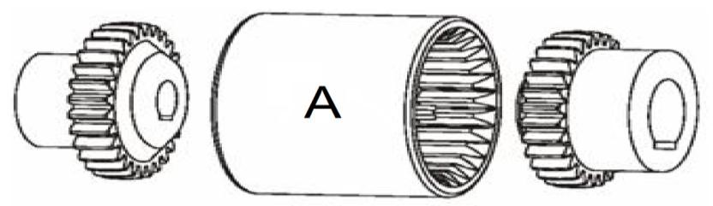

### FIGURE 1

2.2.1 Name the coupling shown in FIGURE 1.

2.2.2 Which group does this coupling belong to?

2.2.3 Name the part labelled A.

(3 × 1) (3)

**[6]**

### QUESTION 3: LIMITS AND FITS

3.1 The ISO system of limits and fits provides standards for the universal use in selecting shaft or hole tolerances.

List FOUR values of the ISO system of limits and fits. (4)

3.2 Briefly describe the interchangeability of parts. (2)

**[6]**

### QUESTION 4: BEARINGS

4.1 Explain the following terms with regard to the properties of bearings:

4.1.1 Compatibility

4.1.2 Conformability

4.1.3 Load capacity

(3 × 1) (3)

4.2 Briefly describe the lubrication of plain bearings by means of oil holes and oil

grooves. (2)

**[5]**

### QUESTION 5: LUBRICATION AND VALVES

5.1 Name THREE lubricating devices associated with the gravity-feed principle. (3)

5.2 Define the term *burning point*. (1)

5.3 State TWO functions of valves used in fluid power systems. (2)

**[6]**

### QUESTION 6: PACKING, STUFFING BOXES, JOINTS AND WATERPIPE SYSTEMS

6.1 State TWO functions of packing and seals. (2)

6.2 State THREE properties of white metal used for packing and seals. (3)

6.3 Name FOUR types of material used to seal threaded pipes. (4)

**[9]**

### QUESTION 7: PUMPS

7.1 State the function of a pump. (1)

7.2 FIGURE 2 shows the diagram of a gear pump.

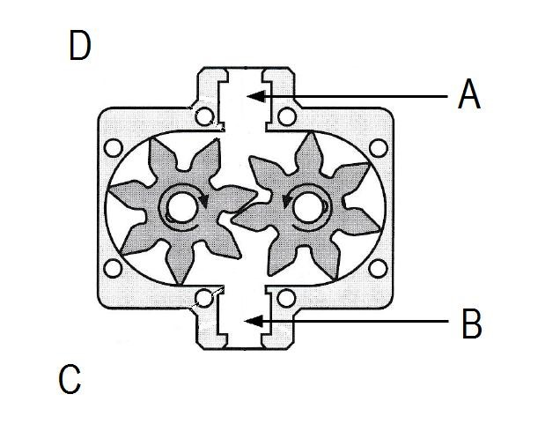

### FIGURE 2

7.2.1 Name the parts labelled A-D in FIGURE 2. Write only the answer next to the letter (A–D) in the ANSWER BOOK. (4)

7.2.2 Name the category under which this pump is classified. (1)

**[6]**

### QUESTION 8: COMPRESSORS

8.1State the main function of a compressor.(1)

8.2 Explain the operation of a lobe compressor. (4)

8.3 Name the TWO categories of air compressors. (2)

**[7]**

### QUESTION 9: V-BELTS, CHAIN DRIVES, GEAR DRIVES AND REDUCTION GEARBOXES

9.1 State the causes of the following V-belt problems:

9.1.1 Small cracks

9.1.2 Swelling

9.1.3 Early failure

(3 × 1) (3)

9.2 Name the TWO gear profiles in relation to gear drives. (2)

9.3 Name THREE types of chains used in industry. (3)

9.4 State TWO purposes of reduction gearboxes. (2)

**[10]**

**TOTAL SECTION A:** **60** **SECTION B**

Answer any TWO of the following three questions.

### QUESTION 10: HYDRAULICS AND PNEUMATICS

10.1 Tabulate THREE differences between a *hydraulic system* and a *pneumatic* *system*. Copy and complete the following table in the ANSWER BOOK.

|  |  |
| --- | --- |
| **HYDRAULIC SYSTEM** | **PNEUMATIC SYSTEM** |
|  |  |

(6)

10.2 Make neat, freehand sketches of the ISO symbols representing the following hydraulic or pneumatic components:

10.2.1 Hydraulic pump

10.2.2 Reservoir

10.2.3 Compressor

10.2.4 Electric motor

10.2.5 Non-return valve

(5 × 1) (5)

10.3 List any FOUR steps that can be followed during the daily maintenance of a pneumatic system. (4)

10.4 List FIVE advantages of pneumatic systems. (5)

**[20]**

### QUESTION 11: CENTRE LATHES

11.1 State TWO functions of lathe steadies (2)

11.2 One method of setting over the tailstock to cut tapers is the graduated sleeve method.

11.2.1 State TWO advantages of the graduated sleeve method of setting

over the tailstock (2)

11.2.2 State TWO disadvantages of the graduated sleeve method of

setting over the tailstock (2)

11.3 The statements below are brief explanations of the TWO types of programming used on the CNC lathes. State the type of programming that each of the statements in questions 11.2.1 and 11.2.2 represent.

11.3.1 All points are taken from a common reference point. (1)

11.3.2 The distance from one point to a second point on a work piece is given without referring to a common reference point. (1)

11.4 FIGURE 3 shows a tapered shaft which has to be turned to the dimensions given.

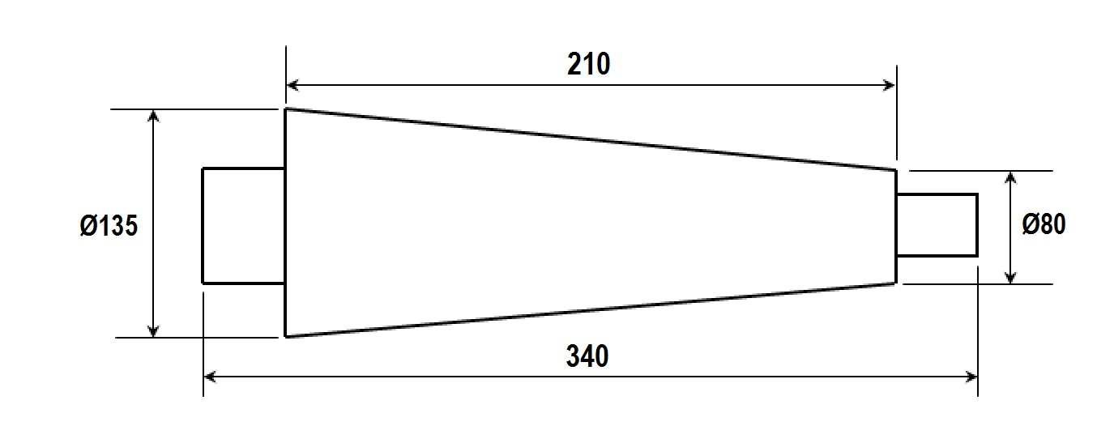

**FIGURE**

**3**

11.4.1Calculate the amount of tailstock set-over.(2)

11.4.2Calculate the included angle of the tapered portion.

(3)

11.5 It takes 8 minutes to take one longitudinal cut along a workpiece with a length of 350 mm on a centre lathe.

Determine the feed of the cutting tool in mm per revolution if the spindle

rotates at 110 r/min. (3)

11.6 A steel pin with a diameter of 50 mm has to be machined on a centre lathe.

Calculate the cutting speed of the tool in m/min if the rotational speed of the

spindle is 950 r/min. (2)

11.7 Name the TWO items on which the helix angle of a screw thread is

dependent. (2)

. **[20]**

### QUESTION 12: MILLING MACHINES AND SURFACE GRINDERS

12.1 FIGURE 4 shows the diagram of the four milling cutters.

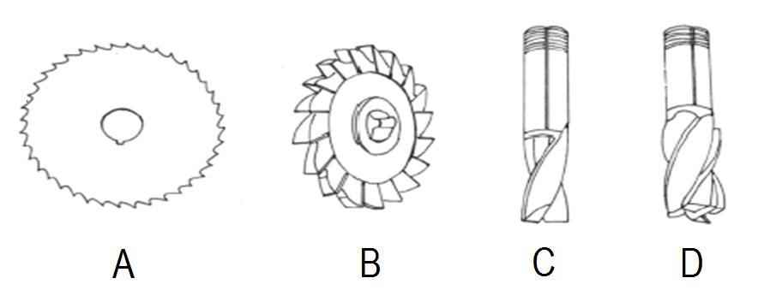

### FIGURE 4

12.1.1 Name the four milling cutters shown in FIGURE 4. Write only the answer next to the letter (A–D) in the ANSWER BOOK. (4)

12.1.2 State ONE use for each of the milling cutters shown in FIGURE 5. (4)

12.2 Calculate the required indexing for an angular groove of 65° using a

Cincinnati dividing head.

|  |  |  |  |  |  |  |  |  |  |  |  |
| --- | --- | --- | --- | --- | --- | --- | --- | --- | --- | --- | --- |
|  | **THE CINCINNATI DIVIDING HEAD** | | | | | | | |  |  |  |
| Side 1 | 24 | 25 | 28 | 30 | 34 | 37 | 38 | 39 | 41 | 42 | 43 |
| Side 2 | 46 | 47 | 49 | 51 | 53 | 54 | 57 | 58 | 59 | 62 | 66 |

(5)

12.3 Explain the following milling terms:

12.3.1 Indexing

12.3.2 Blind slots

(2 × 1) (2)

12.4 Name the TWO types of work tables used on surface grinding machines. (2)

12.5 Give THREE reasons why a workpiece could be scratched when performing

surface grinding. (3)

**[20]**

### TOTAL SECTION B: 40

**GRAND TOTAL:** **100**

Copyright reserved

## FITTING AND MACHING THEORY N2

**FORMULA SHEET**

ƒ =ƒ × T × N



























Copyright reserved